Project Phases 2.0 Requirements Specification

Scope

Overview
The Project Phases component will allow an application to define a project, its phases and all its dependencies. Each phase will be defined by a start date, length of time and any other custom attributes necessary. This will enable the application to automatically adjust the timeline of dependent phases.

This enhancement of the component will provide a more flexible dependency specification. Besides the phase structure will incorporate the execution status and actual execution timestamps.

Logic Requirements

Compatibility
Compatibility with version 1.0 is not required.

Project
In addition to the attributes from the previous version, each project should be associated with a numeric identifier.

Phase Type
A phase type consists of a numeric identifier and a name.

Phase Status
A phase status consists of a numeric identifier and a name. The component has three built in phases – Scheduled, Open and Closed.

Phase
In addition to the attributes from the previous version, the following additions/modifications should be made:
- Add a numeric identifier
- Add a phase type
- Add a phase status
- Phase length should be accurate to seconds
- Fixed start time may or may not be scheduled, but a scheduled start time should always be available to the component user.
- Add an actual start timestamp and an actual end timestamp. They will not be available before the phase is actually started or ended.

Phase Dependency
Phase dependency should be able to specify whether the dependent phase will start before/after the dependency phase starts/ends with a lag time. The lag time should be accurate to seconds.

There should be a way to validate the phase dependencies. If a cyclic dependency is detected, an error should be indicated.

Phase Calculation
If the actual start time or end time is present, the dependent phases should refer to this timestamp instead of the scheduled start time or end time.

Required Algorithms
The algorithm to detect cyclic dependency and the algorithm to calculate project phases must be provided by the designer.

Example of the Software Usage
A project management application could use this component to see how adjusting various phases of a project affect other phases and the overall timeline of a project.

Future Component Direction
A pluggable persistence layer will be added in the future to support the ability of loading and storing a project's phase data. A template mechanism can generate phases for similar project structure.

Interface Requirements

Graphical User Interface Requirements
None.

External Interfaces
Design must adhere to the interface diagram definition. Designer can choose to add more methods to the classes/interfaces, but must keep the ones defined on the diagram as a minimum. Source files can be found in the distribution.
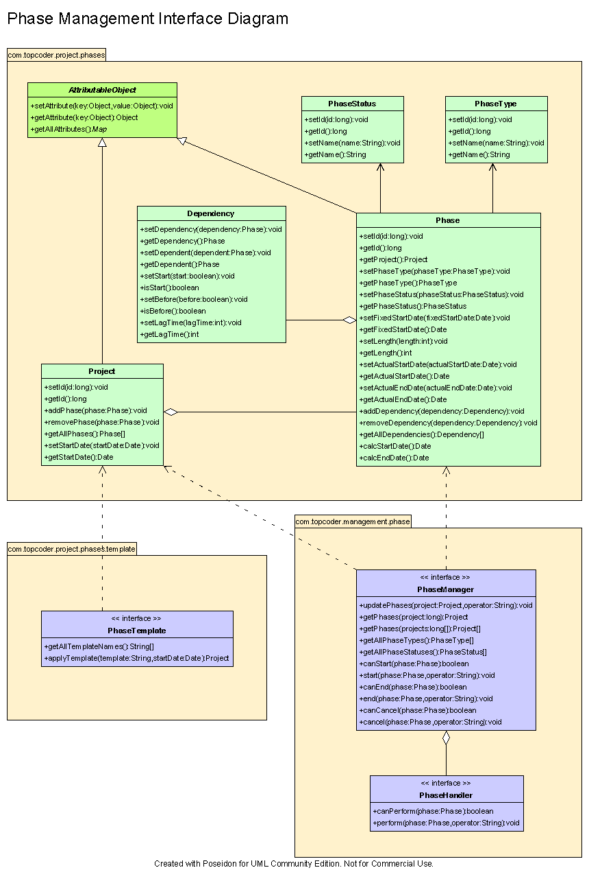

Environment Requirements
- Development language: Java1.4
- Compile target: Java1.4

Package Structure
com.topcoder.project.phases

Software Requirements

Administration Requirements

What elements of the application need to be configurable?
None.

Technical Constraints

Are there particular frameworks or standards that are required?
None.

TopCoder Software Component Dependencies:
None.

**Please review the TopCoder Software component catalog for existing components that can be used in the design.

Third Party Component, Library, or Product Dependencies:
None.

QA Environment:
- Solaris 7
- RedHat Linux 7.1
- Windows 2000
- Windows 2003

Design Constraints
The component design and development solutions must adhere to the guidelines as outlined in the TopCoder Software Component Guidelines.

Required Documentation

Design Documentation
- Use-Case Diagram
- Class Diagram
- Sequence Diagram
- Component Specification

Help / User Documentation
- Design documents must clearly define intended component usage in the ‘Documentation’ tab of Poseidon.

